# Context Report: Cost of Living in Accra

The purpose of this report is to provide context on the financial landscape of Accra for compensation planners, enabling them to make a more informed assessment of what to pay employees based on the cost of living in this city. It takes a look at the costs associated with 5 basic expense categories - namely; food, transportation, groceries, rent and utilities - and provides supporting reference material to assert cost values and qualitatively assess the options available under each category. Using these values, a simple python model and some guiding assumptions, inferences are made to deduce 3 levels of compensation and what they afford a person to do.

## Food

Food in Accra can be divided into 4 main categories:

**Street food vendors**

Street food vendors are the most widespread suppliers of food available in Accra. They provide foods like rice meals, stir-fry noodles, fried foods and a wide array of local dishes.

Given that this category of vendor supports the majority of citizens in Accra, the prices range from 5gh to 20gh for a meal, with food quality often on par with most other establishments. However, these vendors are underserved with water and electricity access, making it a challenge to guarantee health and safety standards, despite their best efforts.

Sample menu:

* 6 pieces of fried yam and 2 sausages -> 5gh
* 6 pieces of fried plantain and beans stew (gob3) -> 5gh
* 1 pack of Jollof/fried rice and chicken -> 10 - 15gh
* Noodle stir fry (indomie) -> 10 - 20gh
* Waakye with trimmings, plantain and fish -> 15 - 20gh

**Food delivery apps**

Food delivery apps are relatively new in Accra (introduced in the last 5 years) and often deliver from established restaurants across a range of prices (15gh - 60gh per meal). The menus are more varied with fast food options available towards the lower end of prices and more diverse options available towards the higher end of prices. The most popular apps are Jumia food and Bolt food with others also serving a similar model with similar prices.

Sample menu:

* [Jumia Food KFC menu](https://drive.google.com/file/d/1b361g6zWJiYSg5zu7SuDfbwRHuH3hLtl/view?usp=sharing)
* [Bolt Food Meggs menu](https://drive.google.com/file/d/187zphtoNWEM1ugL3pq_OHrdsdbfVFra_/view?usp=sharing)
* [Bolt Food Gaia menu](https://drive.google.com/file/d/1osU674oOnIti54SL9fg1JJEM59Ko8TDA/view?usp=sharing)
* [Henny Andos menu](https://drive.google.com/file/d/19dHenznmTESIzMovQQQFS1wLbPOTV3yj/view?usp=sharing)

**Budget-friendly restaurants**

Budget-friendly restaurants, much like those found on food delivery apps, often serve a similar menu at similar prices to those found on food delivery apps. These can either be bought in-person or online with a delivery charge ranging from 15 - 25gh.

Sample menu:

* [KL M-FF.cdr (squarespace.com)](https://static1.squarespace.com/static/5cf3a0d3f78edf0001669341/t/5ee720922d6057213941c7e6/1592205548485/Koffee-Lounge-Menu+%281%29.pdf)
* [Starbites - Zubzz.com (squarespace.com)](https://static1.squarespace.com/static/5cf3a0d3f78edf0001669341/t/5d0f17e0a6630100017c5ca1/1561270343879/Starbites+-+zubzz.com.pdf)
* [Papas Pizza - zubzz.com (squarespace.com)](https://static1.squarespace.com/static/5cf3a0d3f78edf0001669341/t/5d679ba88fc07e00016901c3/1567071148229/Papas+Pizza+-+zubzz.com.pdf)

**Experience restaurants**

These are restaurants that have an average menu item costing 50 - 200gh. They are mostly used when people look to treat themselves or have a celebratory meal. Their menus are often more varied with a diverse range of options available.

Sample menu:

* [Cafe Kwae (squarespace.com)](https://static1.squarespace.com/static/5cf3a0d3f78edf0001669341/t/5ee759c1b8c5f829927216ef/1592220102948/Cafe+Kwae.pdf)
* [Coco+Lounge.pdf (squarespace.com)](https://static1.squarespace.com/static/5cf3a0d3f78edf0001669341/t/6013fd18428d6d104a318bcf/1611922727344/Coco+Lounge.pdf)
* [Le Must (squarespace.com)](https://static1.squarespace.com/static/5cf3a0d3f78edf0001669341/t/5ee6107fb3fb1839cc3490c1/1592135821594/Le+Must+.pdf)
* [La Borracha (squarespace.com)](https://static1.squarespace.com/static/5cf3a0d3f78edf0001669341/t/60cf6b5c23997448e1ecdf0d/1624206207890/La+Borracha.pdf)

## Transportation

Transportation in Accra falls into 3 main categories:

**Public mass transportation**

This category is the most widely used and available form of transportation in Accra and is served by minibuses with 12-15 seats (trotro’s) and loading taxis with 4 seats. They connect most places in Accra with fares ranging from 1gh to 6gh per trip to a single location. However, many locations often require more than 1 vehicle to reach, making the point to point cost of a trip range between 3gh and 15gh, with fares reaching as high as 25gh depending on how far your destination is (eg: Tema to Accra)

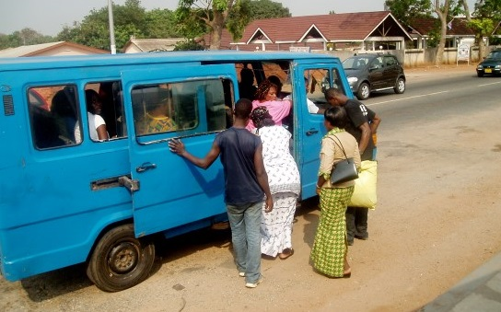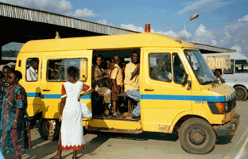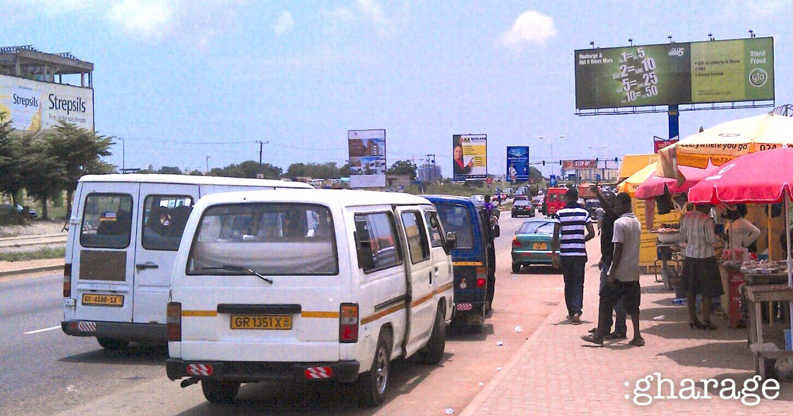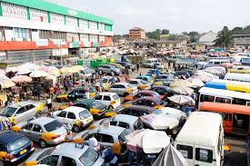

**Taxi Services**

Taxi services in Accra are served mainly by ridesharing apps like Bolt or Uber, or by traditional taxi’s. The business models of these apps and traditional vendors are similar to those in other countries. Using Turntabl as the destination, prices can range from 10gh (for people living within Achimota) to 50gh (for people living in Oyarifa, Tema, Spintex, Kasoa, etc). Ridesharing apps are often 20% cheaper than traditional taxis, however, surge pricing during rush hour can be more than double the base price of a trip.

Examples:

* [Uber from Oyarifa](https://drive.google.com/file/d/1dqmfBdTG7Gld-mgleq5qE8LQxbvH7Pq1/view?usp=sharing)
* [Uber from Tema](https://drive.google.com/file/d/1ir2cNeOWGziI3__GRApUMd1-DR0RiM2F/view?usp=sharing)
* [Uber from Spintex](https://drive.google.com/file/d/1Xk5Fm0JAAxVu3Xt2Ygq-Ue9gKhQXxbHf/view?usp=sharing)
* [Uber from Kasoa](https://drive.google.com/file/d/1omH4wB7tdVN11vmv3bh7jIAgCOSFX087/view?usp=sharing)
* [Uber from Tse Addo](https://drive.google.com/file/d/1exlziJcA4QtUJQt6aE0tlSUkrSCuIKhT/view?usp=sharing)
* [Uber from Adjriganor](https://drive.google.com/file/d/1GBFVTyeBCg3K5MqvxDx_o2_DpF41Gk-P/view?usp=sharing)
* [Uber form Haatso](https://drive.google.com/file/d/1-XYgyUzEiP0witui4KBqabHW64Vkyg9G/view?usp=sharing)

**Private transportation**

Private transportation is the least common mode of transportation for most Turntabl employees. However, for those that use it, fuel cost is the largest limiting factor. The current price of a liter of petrol in Ghana is 6.50gh.

Example:

* [• Ghana: weekly gasoline prices 2020-2021 | Statista](https://www.statista.com/statistics/1200108/weekly-gasoline-prices-in-ghana/)

## Groceries

Groceries are often purchased in 2 main sources:

**Local stores/markets**

Local corner stores are a commonly available option for purchasing everyday groceries. Their options cover the essentials; food ingredients, toiletries, household cleaning supplies, etc. Their prices for most packaged goods are comparable (sometimes slightly higher due to markups and not being able to take advantage of economies of scale) to those sold in supermarkets, with raw food items having the most variation in their prices.

Sample price list:

* 3 tomatoes -> 5gh
* 3 large onions -> 5gh
* 1 clove of garlic -> 1gh
* 3 fingers of ginger -> 1gh
* 1 small bag of scotch bonnet peppers -> 1gh
* 1 kilo of chicken -> 10gh
* 1 kilo of beef -> 12gh

**Supermarkets**

Supermarkets are widely available in Accra with a much larger stock of foodstuffs and items that can take advantage of economies of scale. As such, the prices of most goods are fairly similar across all of them.

Prices:

* [Shopping receipt 1](https://drive.google.com/file/d/147ooFoAdN1ekWkBHOb-G6SbHMEw5muDH/view?usp=sharing)
* [Shopping receipt 2](https://drive.google.com/file/d/1SDJJ0ahlxjL1JcMLkINJyB6Cp-jkor8n/view?usp=sharing)

## 

## Rent

Rent in Accra, like in most cities, is the single largest expense of any individual. The rent landscape is vast, but for the purposes of this report, locations often fall into 4 main categories:

**Low cost, low value (< 800gh/month)**

These are properties often located at the outskirts of town with little to no public servicing. Due to their locations and costs, these properties are unfurnished, may often have higher maintenance costs, less stable electricity and water supply, lower internet coverage and higher security concerns depending on the area.

Examples:

* [Apartment in Community 22, Tema, hosted by Gumption Properties (edanra.com)](https://www.edanra.com/greater-accra/2-bedroom-apartment/0pWUjhV3yxE6cj7d24eJ)
* [Apartment in Gbetsile, Ghana, hosted by Gumption Properties (edanra.com)](https://www.edanra.com/greater-accra/2-bedroom-apartment/osNRdkQa9E9jmOxdE7kA)
* [Apartment in Teshie Malick , hosted by Samuel adobah (edanra.com)](https://www.edanra.com/greater-accra/1-bedroom-apartment/ifgNXBQDv9bgcTgmNJQF)

**high cost, mid value (800 - 1200gh/month)**

These are properties located either at the outskirts or closer to town with decent servicing. These properties may often have lower maintenance costs but are also unfurnished, stable access to electricity and water, good internet coverage and lower security concerns depending on the area.

Examples:

* [Apartment in Achimota Golf hills, hosted by Melton Global Properties (edanra.com)](https://www.edanra.com/greater-accra/1-bedroom-apartment/KfUqhduAZpMMsE9IZUIP)
* [Apartment in North Legon, hosted by Melton Global Properties (edanra.com)](https://www.edanra.com/greater-accra/1-bedroom-apartment/JFmu7ZWq5f6J1rEIw0al)
* [Apartment in Haatso, hosted by Melton Global Properties (edanra.com)](https://www.edanra.com/greater-accra/1-bedroom-apartment/muAIgKSwR7qRsc3yMTMH)

**Higher cost, high value (1200 < 2000gh/month)**

These are properties located closer to town with good servicing. These properties often have minimal maintenance costs and might be semi-furnished, good access to electricity and water, good internet coverage and little to no security concerns depending on the area.

Examples:

* [Apartment in East Legon, hosted by Med Properties (edanra.com)](https://www.edanra.com/greater-accra/1-bedroom-apartment/27hU8F4EQaZJmLMJKA71)
* [Apartment in Dome Pillar 2, hosted by Melton Global Properties (edanra.com)](https://www.edanra.com/greater-accra/2-bedroom-apartment/9PGeHxegup2fJXjBB2X7)
* [Apartment in Achimota, hosted by John Koffi (edanra.com)](https://www.edanra.com/greater-accra/2-bedroom-apartment/5nLzgVKVQJwMG4C2hFe0)

**Extremely high cost, high value (2000gh/month +)**

These are properties located closer to town with very good servicing. These properties often have little to no maintenance costs, great access to electricity and water, great internet coverage and almost no security concerns, given that they may often be located in gated communities or have some form of security.

Examples:

* [Apartment in Accra, Ghana, hosted by Manstineproperties and real estate (edanra.com)](https://www.edanra.com/greater-accra/2-bedroom-apartment/fAA6ThpM2OuPQX1n8MGk)
* [Apartment in Dzorwulu, hosted by Melton Global Properties (edanra.com)](https://www.edanra.com/greater-accra/2-bedroom-apartment/IRXg6UDEV1mj8XAgsfHI)
* [Apartment in American House, hosted by Melton Global Properties (edanra.com)](https://www.edanra.com/greater-accra/2-bedroom-apartment/IEKI1WSGDW4B1D2L4pIR)
* [Apartment in Dzorwulu, hosted by Melton Global Properties (edanra.com)](https://www.edanra.com/greater-accra/2-bedroom-apartment/vfUK4CdIAc3Q0CVC1njE)

## Utilities

There are 2 main utility costs in Accra:

**Electricity**

Electricity is the highest utility cost that can range from 100 - 300gh a month depending on the size of your household and consumption. Electricity is mostly stable in Accra. As such, most people do not have or use generators so external electricity costs are negligible.

**Water**

Water costs vary depending on where you live and if your area is served by Ghana water or not. In the event that it is, costs can range from 100 to 250gh. However, if the supply is unstable or nonexistent, the cost of filling a polytank of 1000L+ can range from 50 - 100gh

Examples:

* [Utility bills](https://drive.google.com/file/d/1615nMMinSecHQoP39KfuA849Ylyiib9e/view?usp=sharing)

## 

## 

## Savings, Personal Spending and Inferences

Using the [50/30/20 rule of thumb](https://www.investopedia.com/ask/answers/022916/what-502030-budget-rule.asp) as a reference, a simple [python model](https://colab.research.google.com/drive/1xf77Ux2sfnjgMcY9VBvzXGd38HTZRGyo#offline=true&sandboxMode=true) was created to calculate expected income after-tax based on expenses and the above-stated values as input data; the following analysis was conducted.

Assumptions:

* The cost of any given meal does not exceed the cost of a single meal.
* A person has two main meals and one small meal (2.5) a day.
* A person makes 2 trips a day; one to work and one back home.
* A person needs an extra quarter (0.25) of their daily expenses to account for other hidden expenses for that day.
* A person working a full time job must be able to save at least 20% (0.2) of their income.
* A person has the same costs on weekends and off days as they do on a given workday.
* A person earns 80% (0.8) of their work compensation for their weekends and days off.
* A person working a full time job must be able to afford all necessary expenses.

Using these assumptions and other known values, the following model settings were used:

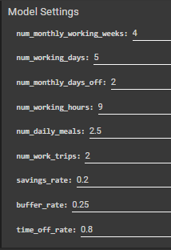

*Note*: `time_off_pay` (used in the calculation of `personal_cash` for weekends and holidays) is a sum of necessary expenses and 80% of `work_compensation` for a day. As such, a portion of the `discretionary_income` value can be assumed to be used on those expenses. However, it all remains as part of `discretionary_income` as it is also assumed that this amount is up to the individual to decide its use.

**Level 1: Minimum Cover Baseline**

Using the upper bounds of values in the lowest estimates and an hourly rate of 0, the following results were obtained.

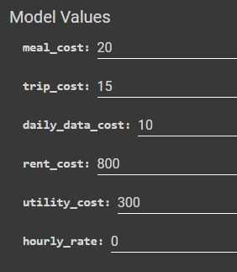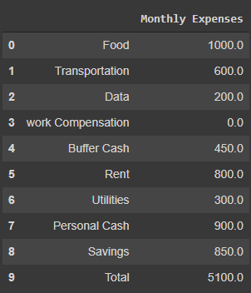

Total Compensation: GHC 5100.0

Discretionary income: GHC 900.0

Savings: GHC 850.0

Ratio: (65.69) / (17.65 ~ 14.31) / (16.67 ~ 20.0)

In this model, while the given individual is able to save roughly 20% of their income, more than 50% of their income is spent on necessary goods and services which translates into a more constrained financial outlook for the individual's wants.

Note that the values input only account for spending on street food, public mass transportation, low cost, low value housing and basic utilities. While it is not a given that this is all anyone would spend their income on, it suggests that there will be minimal chance of participation in higher levels of each expense bracket if the given individual is to spend within these limits.

**Level 2: Comfortable Baseline**

Using the median values of the median estimates and an hourly rate of 15gh, the following results were obtained.

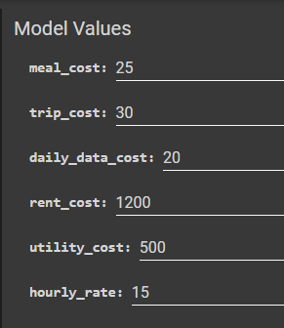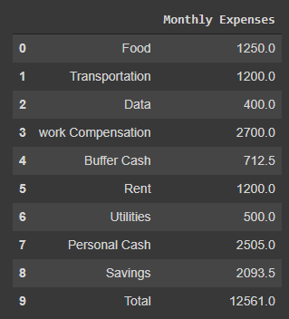

Total Compensation: GHC 12546.0

Discretionary income: GHC 5230.0

Savings: GHC 2091.0

Ratio: (41.65) / (41.69) / (16.67 ~ 20.0)

In this model, the given individual is able to save roughly 20% of their income while spending less than 50% of their income on necessary goods and services, leaving them with more financial options.

Note that the input values allow the individual to spend on restaurant food, taxi service transportation in closer areas, high cost, mid value housing and higher utilities. While this income may only account for basic levels of comfort, it suggests that the individual will be able to participate more in the wider economy, and unlocks spending on personal care items and services that would otherwise be out of their budgets such as consumer goods, clothes, social events and other similar services.

**Level 3: Full Cover Baseline**

Using the upper bound values of the median estimates and an hourly rate of 25gh, the following results were obtained.

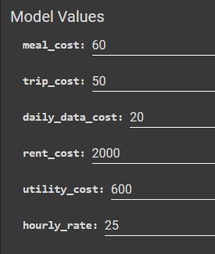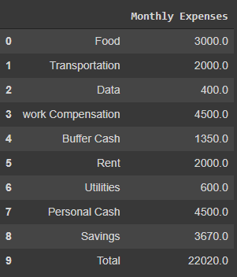

Total Compensation: GHC 22020.0

Discretionary income: GHC 9000.0

Savings: GHC 3670.0

Ratio: (42.46) / (40.87 ~ 37.54) / (16.67 ~ 20.0)

In this model, the given individual is able to save roughly 20% of their income while spending less than 50% of their income on necessary goods and services, leaving them with far more financial options, all while greatly improving their level of comfort.

Note that the input values fully account for spending in any budget-friendly restaurant, taxi service transportation from further locations, higher cost, high value housing and all utilities. This income not only gurantees a basic level of comfort, it ensures that the individual will be able to participate in the wider economy, and encourages spending on personal care items and services such as consumer goods, clothes, social events and other similar services.

It also opens up the possibility for wealth accumulation, offering the individual the opportunity to save towards larger quality of life expenses like home improvements, consumer electronics, family holidays and personal vehicles.

## Conclusion

These numbers are meant to serve as minimum guidelines for compensation consideration for a single individual and their personal expenses. The assesment does not take into account other expense factors like dependents, breadwinner status in household, external financial obligations like loans and many others. However, all of these are factors that would need to be considered when thinking about compensation for full time employees. It is the hope of this document that all the information provided has a positive impact on compensation considerations, and helps present an accurate view of the expenses faced by full time employees and participants in the economy of Accra.